|  |
| --- |
| CENTRAL ACADEMY |

Term 2 Examination: 2021-2022

CLASS XII (Commerce)

Time: 2 Hours Applied mathematics (241) (SET- A) Marks: 40

**General Instructions:**

* The question paper is divided into 3 sections – A, B and C
* Section A comprises of 6 questions of 2 marks each. Internal choice has been provided in two questions.
* Section B comprises of 4 questions of 3 marks each. Internal choice has been provided in one question.
* Section C comprises of 4 questions. It contains one case study based question. Internal choice has been provided in one question.
* All the questions are compulsory.
* 20 minute additional time will be given for reading the question paper.

**SECTION A**

1. The supply function for a commodity is . If 10 units of goods are sold, then find the producers surplus.

OR

A manufacturer's marginal revenue function is given by MR. If the production is increased from 5 to 10 units, then find increase in revenue.

2. A simple random samples of 50 items from a population with  resulted in a sample mean of 32. Find a 90% confidence interval for the population mean. 

3. Obtain the five year moving averages for the following series of observations:

|  |  |  |  |  |  |  |  |  |
| --- | --- | --- | --- | --- | --- | --- | --- | --- |
| Year | 1995 | 1996 | 1997 | 1998 | 1999 | 2000 | 2001 | 2002 |
| Annual Sales (in ten thousand Rs.) | 3.6 | 4.3 | 4.3 | 3.4 | 4.4 | 5.4 | 3.4 | 2.4 |

4. Corner points of the feasible region determined by the system of linear constraints are (0, 3), (1, 1) and (3, 0). Let , where  Find the condition on *p* and *q*, so that the minimum of Z occurs at (3, 0) and (1, 1).

5. Vishal invested Rs. 32000 in a mutual fund in year 2015. The value of mutual fund increased to Rs. 57600 in year 2021. Calculate the compound growth rate of his investment.

(given, (1.8)1/6 =1.1029)

6. Mr. Taneja purchased 100 shares of a company that cost Rs.250 each. After one year the price of each share rose to Rs. 300. Assuming that there no trading costs and no dividends. Find the nominal rate of return on the investment.

OR

What sum of money is needed to invest now, so as to get Rs. 6000 at the beginning of every month forever, if the money is worth 9% per annum compounded monthly?

**SECTION B**

7. The average number of articles produced by two machines per day are 150 and 100 with S=18. On the basis of records of 14 day's production, can you regard both machines equally efficient at 1% level of significance? (given, )

8. Fit a straight line trend equation by the method of least squares and estimate the trend value.

|  |  |  |  |  |  |  |  |  |
| --- | --- | --- | --- | --- | --- | --- | --- | --- |
| Year | 1991 | 1992 | 1993 | 1994 | 1995 | 1996 | 1997 | 1998 |
| Values | 80 | 90 | 92 | 83 | 94 | 99 | 92 | 104 |

9. A bond of face value Rs. 1000 matures in 5 years. Interest is paid semi-annually and bond is priced to yield 8% p.a. If the present value of bond is Rs. 800, find the annual coupon rate.

(given, (1.04)-10=0.6761)

10. Evaluate: .

OR

Evaluate: .

**SECTION C**

11. A manufacturer makes two products A and B. Product A sells at Rs. 200 per unit and takes 30 minutes to make. Product B sells at Rs. 300 per unit and takes 1 hour to make. There is a permanent order of 14 units of product A and 16 units of product B. A working week consists of 40 hours of production and weekly turnover must not be less than Rs. 10,000. If the profit on each of the product A is Rs. 20 and on product B is Rs. 30, then how many cake of each should be produced so that the profit is maximum? Find the maximum profit by forming an LPP and solve it graphically.

12. A loan of Rs. 400000 at the interest rate of 6.75% per annum compounded monthly is to be amortized by equal payment at the end of each month for 10 year, find

(i) the size of each monthly payment.

(ii) the principal outstanding at the beginning of 61st month.

[given (1.005625)120 = 1.9603 and (1.005625)60 =1.4001]

OR

The cost of a machine purchased 2 year ago depreciates at the rate of 20% every year. If its present worth is Rs. 315600, find

(i) its purchase price.

(ii) its value after 3 year.

13. A machine is bought for Rs. 320000. Its effective life is 8 year, after which its salvage value would be Rs. 25000. It is decided to create a sinking fund to replace this machine at the end of its effective life by making half yearly payments that will earn an interest of 8% per annum compounded half yearly. If it is known that the cost of machine increases by 5% per annum. Calculate the amount of each payment to the sinking fund.

[given, (1.04)16 = 1.8730 and (1.05)8 =1.4774]

14. Ramesh deposited some amount in bank. We have very well known that, if the interest is compounded continuously, the principal changes at the rate equal to the product of the rate of bank interest per annum and the principal.

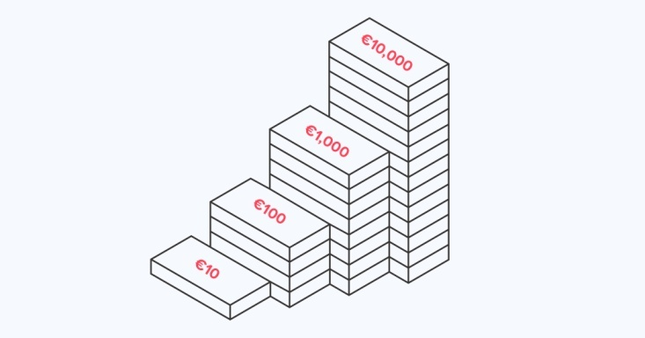

Compound

Amount

1. If the interest is compounded continuously at 5% per annum, find the number of years in which the amount of Rs. 100 will be double of itself.
2. At what interest rate will Rs. 100 double itself in 10 years? (given, loge 2=0.6931)